# 

# What is Sahi?

Sahi is a free open source test automation tool for web applications. A **free version** provides key testing functionality with a **payed version** giving extended features for companies.

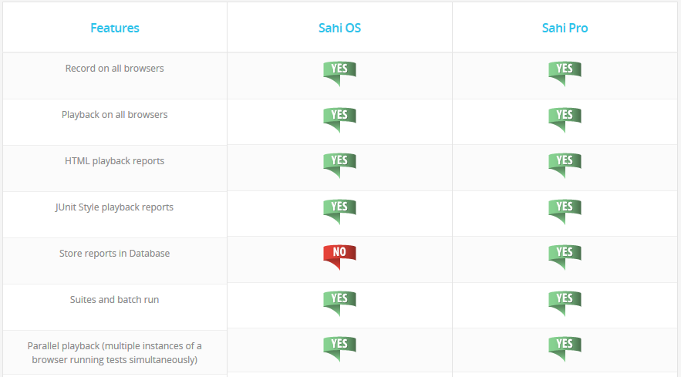

Figure 1 Sahi Features

Currently a single user licence can be **purchased for $695** per year with percentage discounts for groups. Other **payed features** are as follows:

* Distribute tests across machines
* Anchor Button on Controller to easily establish “near” and “in” relations
* View recorded steps in Controller
* Script Editor to easily create functions
* Excel Framework
* Custom report generation
* Take Snapshots
* Side by Side Compare Logs
* Flex automation
* Automatically accept SSL certificates
* Ability to build repository of HTML Elements while recording

Similar to another testing tool called **selenium**, Sahi **automates** the behaviour of a **web browser** through user events like clicking and typing in some text. The tool can then check the data in the website to make sure that the outcome of the actions is as expected through **assertions**.

The key functionality of simulating a user’s actions and recording the actions works well with an **emphasis on functionality** rather than on a good looking resizable interface. The interface of Sahi in the browser will become skewed for example if it **is resized**.

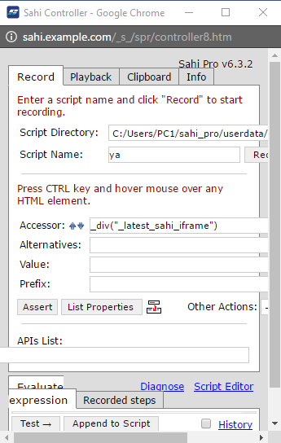

Figure 2 skewed sahi

Selenium is a much more popular testing tool of this type with a larger community for support, which could be attributed to better marketing. Users have reported that Sahi performs faster and with less problems for browsers in particular IE. The advantage of using Sahi is in not having to explicitly install a **browser driver plugin**. Sahi provides **less free feature** compared to its competitors, which is not a fair comparison of **usability and functionality**. (stackexchange, 2016)

The installation in Windows is straight forward. After downloading the software, a licence key is emailed, to be entered when it is first run. Sahi runs as a Java application that opens a private browsing window for testing.